KICSIT
PROJECT REPORT

FRUIT VISION AI
AI-Based Fruit Detection Android Application

Submitted By | Talha Aamir
Registration Number | Not provided
Program / Section | BSCS – 5A
University | KICSIT
Submitted To | ____________________________

Line of app: Fruit_AI_Detection_App

Table of Contents
1. Abstract
2. Introduction
3. Problem Statement
4. Project Objectives
5. Scope of the Application
6. Tools and Technologies
7. System Design and Working
8. Main Application Screens
9. Android Studio Project Structure
10. AI Model Integration
11. Testing and Sample Output
12. Limitations
13. Future Enhancements
14. Conclusion
15. References

1. Abstract
Fruit Vision AI is an Android application developed to demonstrate fruit image detection using an Artificial Intelligence model. The user can select a fruit image from the phone gallery, take a photo with the camera, or try the sample fruit options available on the home screen. The app processes the selected image through a TensorFlow Lite (.tflite) model and displays a predicted fruit name with a confidence value and additional information on the result screen.
The application uses a simple blue-and-white user interface. It contains a splash screen, login screen, home screen, and detection result screen. A pre-trained TensorFlow Lite model is included in the Android project assets. This report explains the app screens, project files, model integration, working process, and possible improvements.

2. Introduction
Fruit identification can be useful in shopping, food handling, and basic fruit information systems. Fruit Vision AI provides a mobile interface where a user can submit an image and receive an AI-based prediction. The main purpose of this project is to integrate an image classification model into an Android application and present its output in an understandable way.
The project is implemented as an Android app using Java-based application classes and XML layout resources. TensorFlow Lite is used to run the trained model on the Android device.

3. Problem Statement
Identifying a fruit from an image manually may take time, especially when a user is unfamiliar with the fruit. The project addresses this basic problem by providing an Android application that accepts a fruit image and predicts its class using an image classification model.

4. Project Objectives
- Develop a simple and user-friendly Android application for fruit image detection.
- Provide splash, login, home, and result screens.
- Allow users to take a photo or choose an image from the gallery.
- Integrate a TensorFlow Lite pre-trained model into the Android project.
- Display the predicted fruit name and model confidence on the result screen.
- Provide sample fruit options for quick testing.

5. Scope of the Application
The home screen displays five supported fruit classes: Apple, Banana, Orange, Strawberry, and Mango. It provides camera and gallery options as well as quick sample buttons. The result interface shows the detected fruit, AI confidence, a health/freshness percentage, and general nutritional or storage information. These additional values are app-displayed estimates or informational content; they should not be treated as a medical, laboratory, or scientifically validated food-quality measurement.

6. Tools and Technologies
Tool / Technology | Purpose
Android Studio | Development environment used to build the Android application.
Java | Application programming language used for Android activity classes.
XML | Used to design the app screens and UI layouts.
TensorFlow Lite | Runs the image classification model on the Android device.
model.tflite | Pre-trained model file included in the app assets.
labels.txt | Stores the class labels used to interpret model predictions.
Android APK | Installable package generated from the Android project.

7. System Design and Working
The general working sequence of the application is:
- The app starts and displays the Fruit Vision AI splash screen.
- The login screen appears. The user can sign in or continue as a guest.
- The home screen provides camera, gallery, and quick sample fruit options.
- The user supplies a fruit image.
- The application prepares the image and sends it to the TensorFlow Lite classifier.
- The model produces class predictions. The app uses the class labels to identify the predicted fruit.
- The result screen displays the predicted fruit name, confidence score, and related information.

8. Main Application Screens

8.1 Splash Screen
The splash screen is the first screen shown when the application is launched. It displays the app name, Fruit Vision AI, a circular logo, the subtitle “AI-Powered Fruit & Health Detection”, and a loading indicator. Its purpose is to introduce the application while the next screen is prepared.
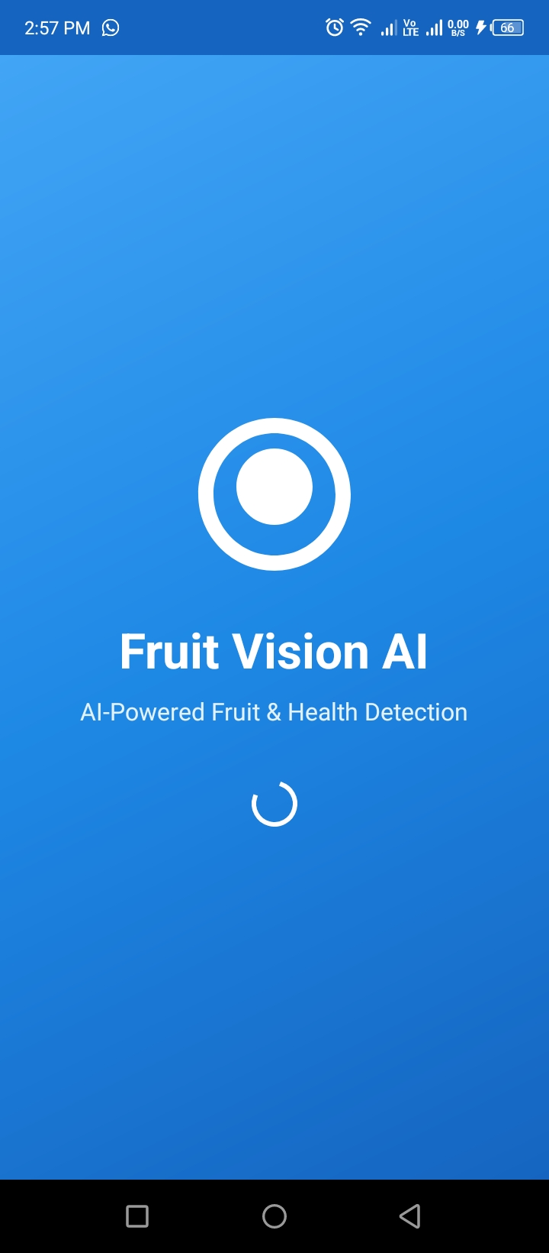
Figure 1: Fruit Vision AI splash screen.

8.2 Login Screen
The login screen displays the Fruit Vision AI branding and a “Welcome Back” message. It contains an email or username field, a password field with a visibility icon, a Sign In button, and a Continue as Guest button. The guest option provides a way to proceed without entering login details.
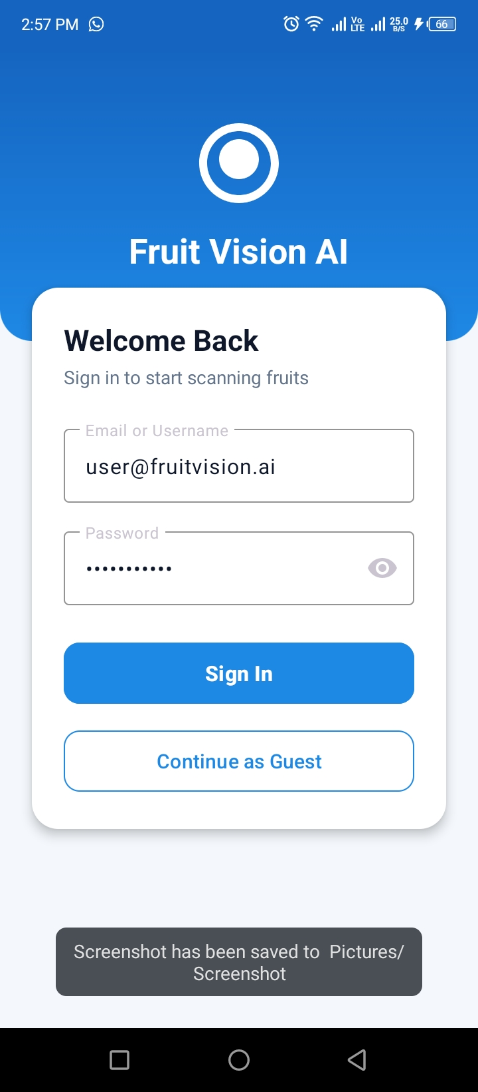
Figure 2: Login screen with sign-in and guest options.

8.3 Home Screen
The home screen is the main dashboard of the application. It contains the title Fruit Vision AI and the subtitle “Scan & Detect Fruit Quality”. Two main cards allow the user to take a photo or choose an image from the gallery. A Quick Test Samples section provides sample fruit choices. The Supported Fruits panel lists five classes: Apple, Banana, Orange, Strawberry, and Mango.
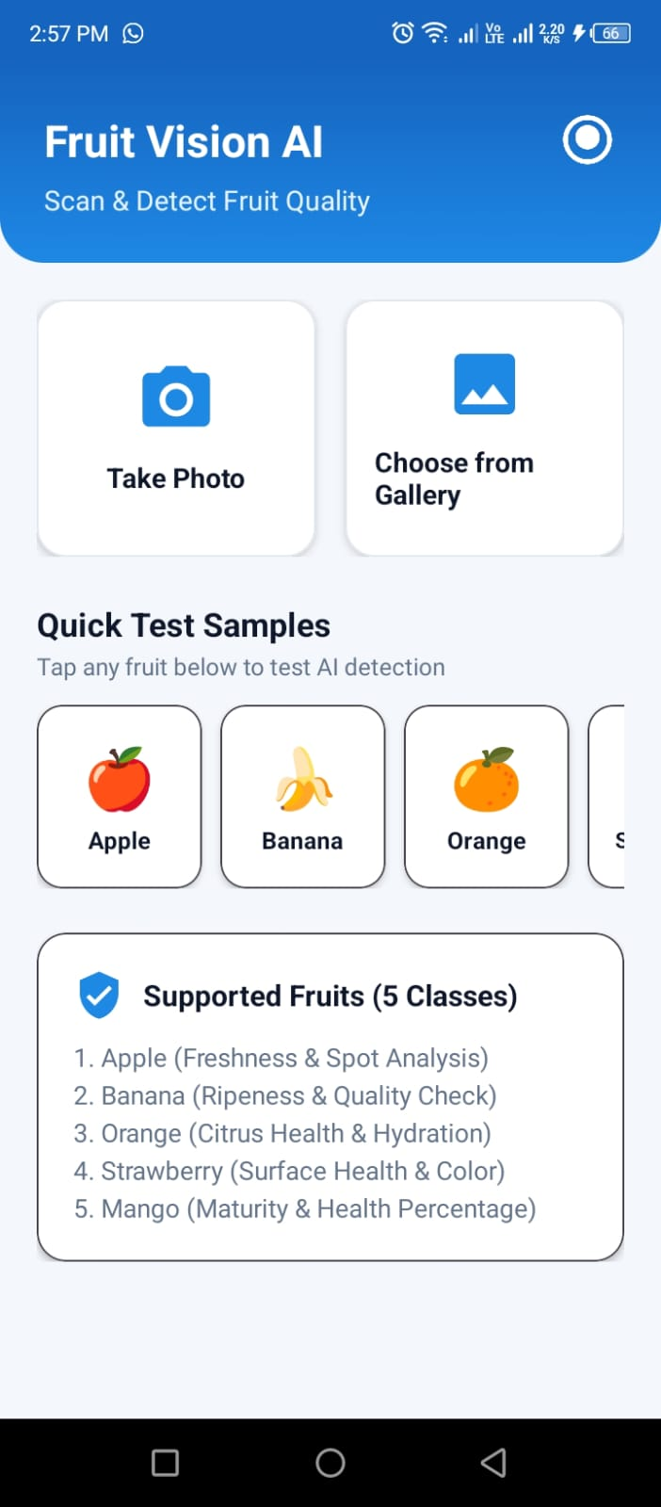
Figure 3: Home screen showing image input options and supported fruit classes.

8.4 Detection Result Screen
After image processing, the result screen presents the selected or processed fruit image and the predicted fruit name. The example screenshot displays Apple with an AI confidence value of 92% and a Health & Freshness value of 98%. It also shows a quality message and a Nutritional & Freshness Info section. These values represent the example output shown by the application and are not a claim of independently measured model accuracy or validated freshness detection.
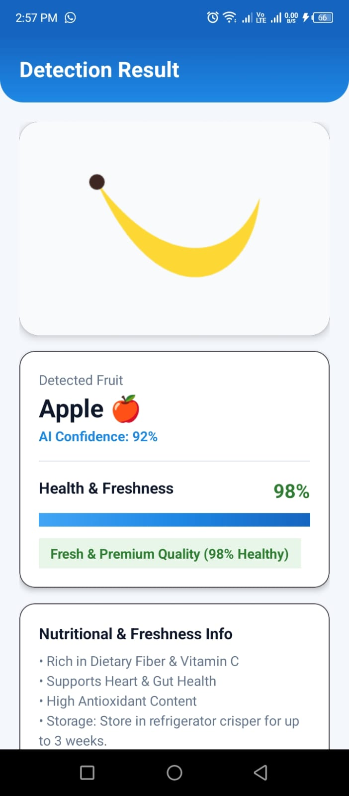
Figure 4: Example detection result screen.

9. Android Studio Project Structure
The Android Studio screenshots show the main Java package, model assets, XML layout resources, drawable resources, and the generated debug APK. The visible project package is com.example.fruit_detection_app.

9.1 Java Classes
Class | Role (based on project structure)
MainActivity | Main application activity / entry point shown in the project structure.
SplashActivity | Controls the splash screen flow.
LoginActivity | Handles the login screen.
HomeActivity | Controls the home screen and its image/sample options.
ResultActivity | Displays the fruit detection result.
FruitClassifier | Classifier helper responsible for using the model for fruit prediction.
FruitData | Data-related class used by the application.
SampleFruitHelper | Helper class for sample fruit testing.

9.2 XML Layout Files
- activity_splash.xml – splash screen layout.
- activity_login.xml – login screen layout.
- activity_home.xml – home screen layout.
- activity_result.xml – detection result layout.
- activity_main.xml – main activity layout.

9.3 Assets and Drawable Resources
The assets folder contains model.tflite and labels.txt. The drawable folder contains UI resources such as bg_card_rounded.xml, bg_header_gradient.xml, bg_splash_gradient.xml, ic_camera.xml, ic_fruit_logo.xml, ic_gallery.xml, and ic_health_shield.xml. These resources support the app's blue-and-white appearance, icons, and rounded interface elements.
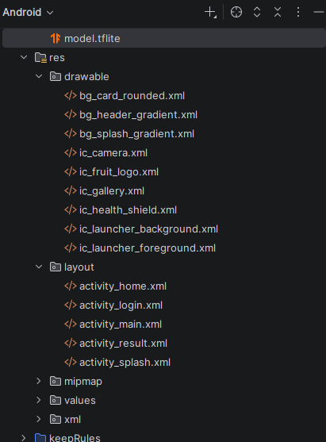
Figure 5: Android Studio resource and layout files.
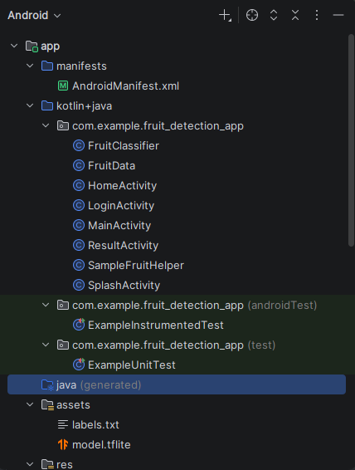
Figure 6: Java classes and model assets in the Android project.
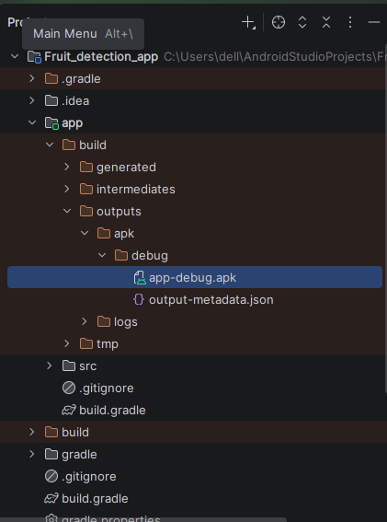
Figure 7: Generated app-debug.apk in the Android Studio build output.

10. AI Model Integration
The project includes a TensorFlow Lite model file named model.tflite inside the app's assets folder. TensorFlow Lite is designed to run machine-learning models on mobile and embedded devices. The application's FruitClassifier class is present in the Java package and is intended to connect the image input with the model inference process. The labels.txt file provides the fruit class names that correspond to the model output.
A pre-trained model means that the model's weights were trained before being placed in the Android application. The Android app uses the model for prediction; the screenshots do not show model training being performed inside Android Studio. The exact training dataset, model architecture, input dimensions, and measured test accuracy were not visible in the supplied screenshots, so they are not specified as verified facts in this report.

11. Testing and Sample Output
The provided screenshots demonstrate that the app opens to the splash screen, presents the login screen, displays the home dashboard, and shows a detection result. The home screen lists five fruit classes and offers camera, gallery, and sample testing options. The result screenshot is an example in which the displayed prediction is Apple, with 92% AI confidence and 98% health/freshness.
For a complete evaluation, each fruit class should be tested with multiple real images under different lighting conditions and backgrounds. The predicted label should be compared with the actual fruit class, and a separate test set should be used to calculate accuracy. No numerical test accuracy is claimed in this report because no evaluation results or test dataset were provided.

12. Limitations
- Predictions depend on the quality, lighting, angle, and clarity of the input image.
- The model can only classify the classes it was trained to recognize.
- A confidence score is not the same as a guaranteed correct prediction.
- Freshness and health percentages should be validated separately before being used for real food-quality decisions.
- The supplied screenshots do not provide details about the model's training dataset or measured accuracy.

13. Future Enhancements
- Add more fruit categories and improve the training dataset.
- Evaluate the model using a separate test dataset and report precision, recall, and accuracy.
- Improve image preprocessing and confidence handling.
- Add a history page to save previous scans.
- Provide multilingual support and clearer guidance when an image cannot be classified.
- Validate freshness estimation with an appropriate dataset and testing method.

14. Conclusion
Fruit Vision AI is an Android-based fruit detection project that combines a simple mobile interface with a TensorFlow Lite pre-trained image classification model. The application provides a splash screen, login and guest access, a home screen with camera/gallery/sample options, and a result screen that displays the predicted fruit name and confidence. The Android Studio project structure includes Java activity and helper classes, XML layouts, drawable resources, model.tflite, and labels.txt. The project demonstrates how an AI model can be integrated into an Android application. Further testing and model evaluation can improve its reliability.

15. References
- TensorFlow Lite documentation, https://www.tensorflow.org/lite
- Android Developers documentation, https://developer.android.com/
- Project files and application screenshots supplied by the student.

